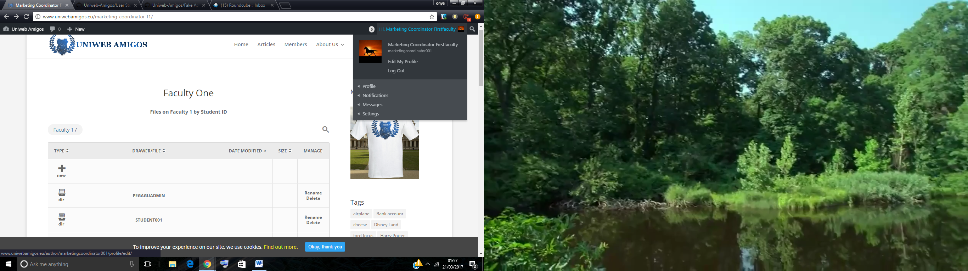

I need to be able to login as a Marketing Coordinator, so I could access the dashboard on this web application, control my account and use my privileges.

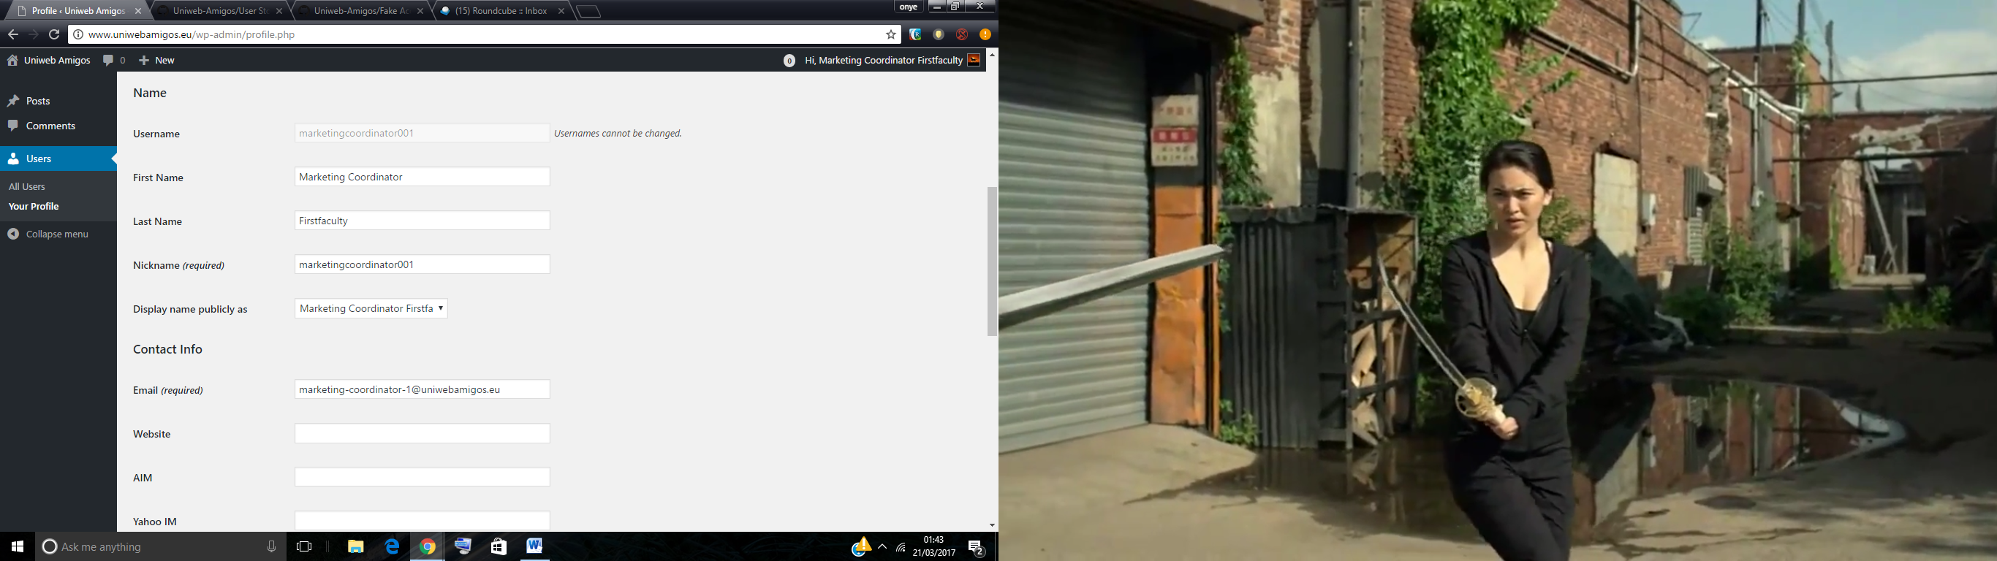

I need to be able to change my password and other details on the dashboard, such as address or a phone number, because this information may change.

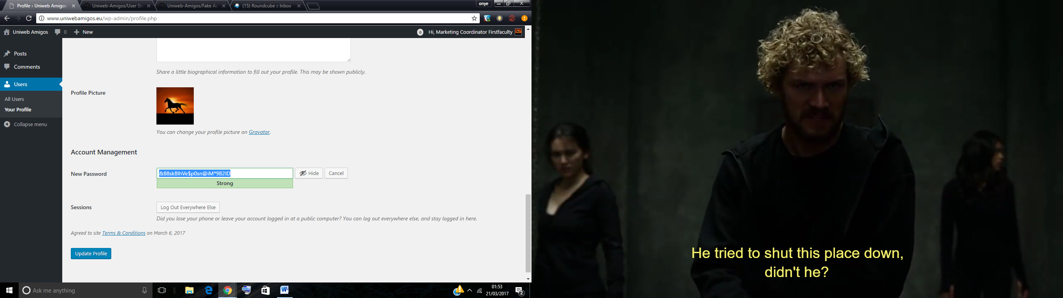

I need to be able to change my password and other details on the dashboard, such as address or a phone number, because this information may change.

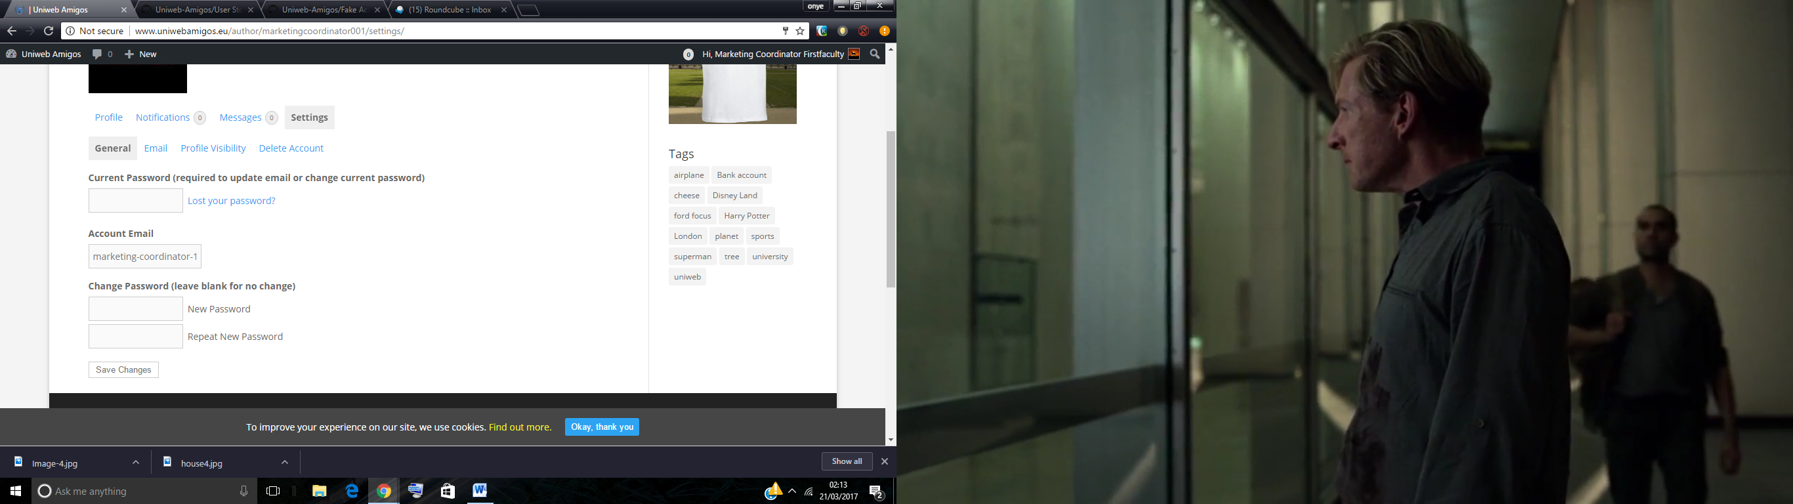

&88skBlhVe$p0sn@iM\*9B2ID

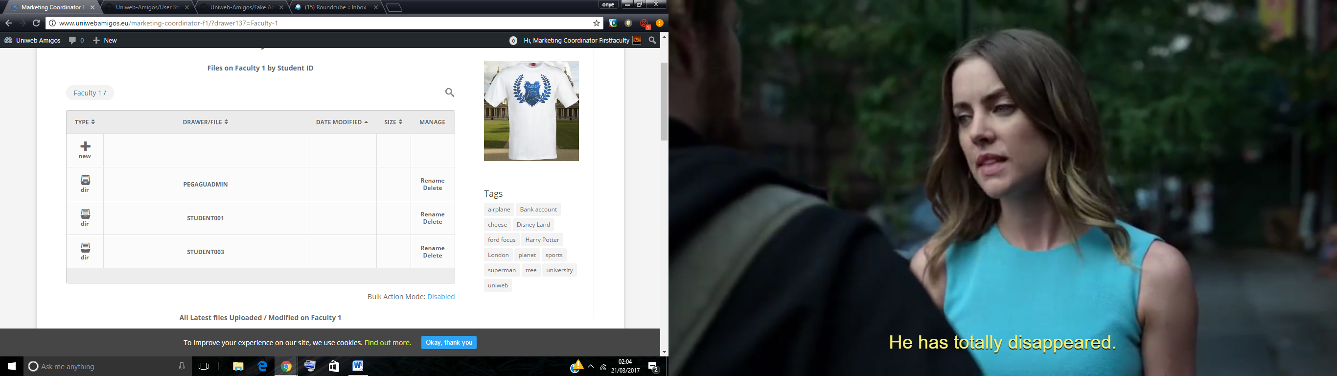

I need to have an access to all submissions within my faculty, so I could manage them

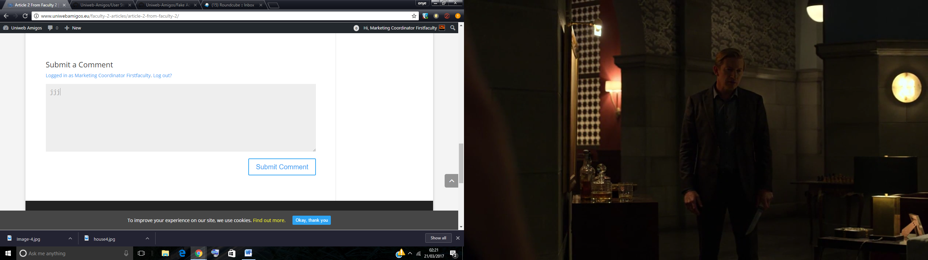

I need to be able to leave a comment on submissions, so that students would know what needs to be edited on their submissions.

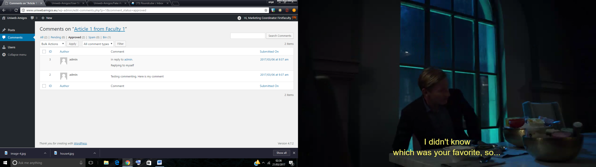

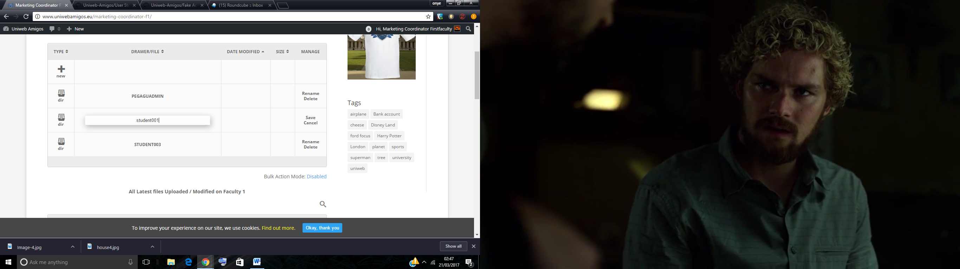

I can rename..

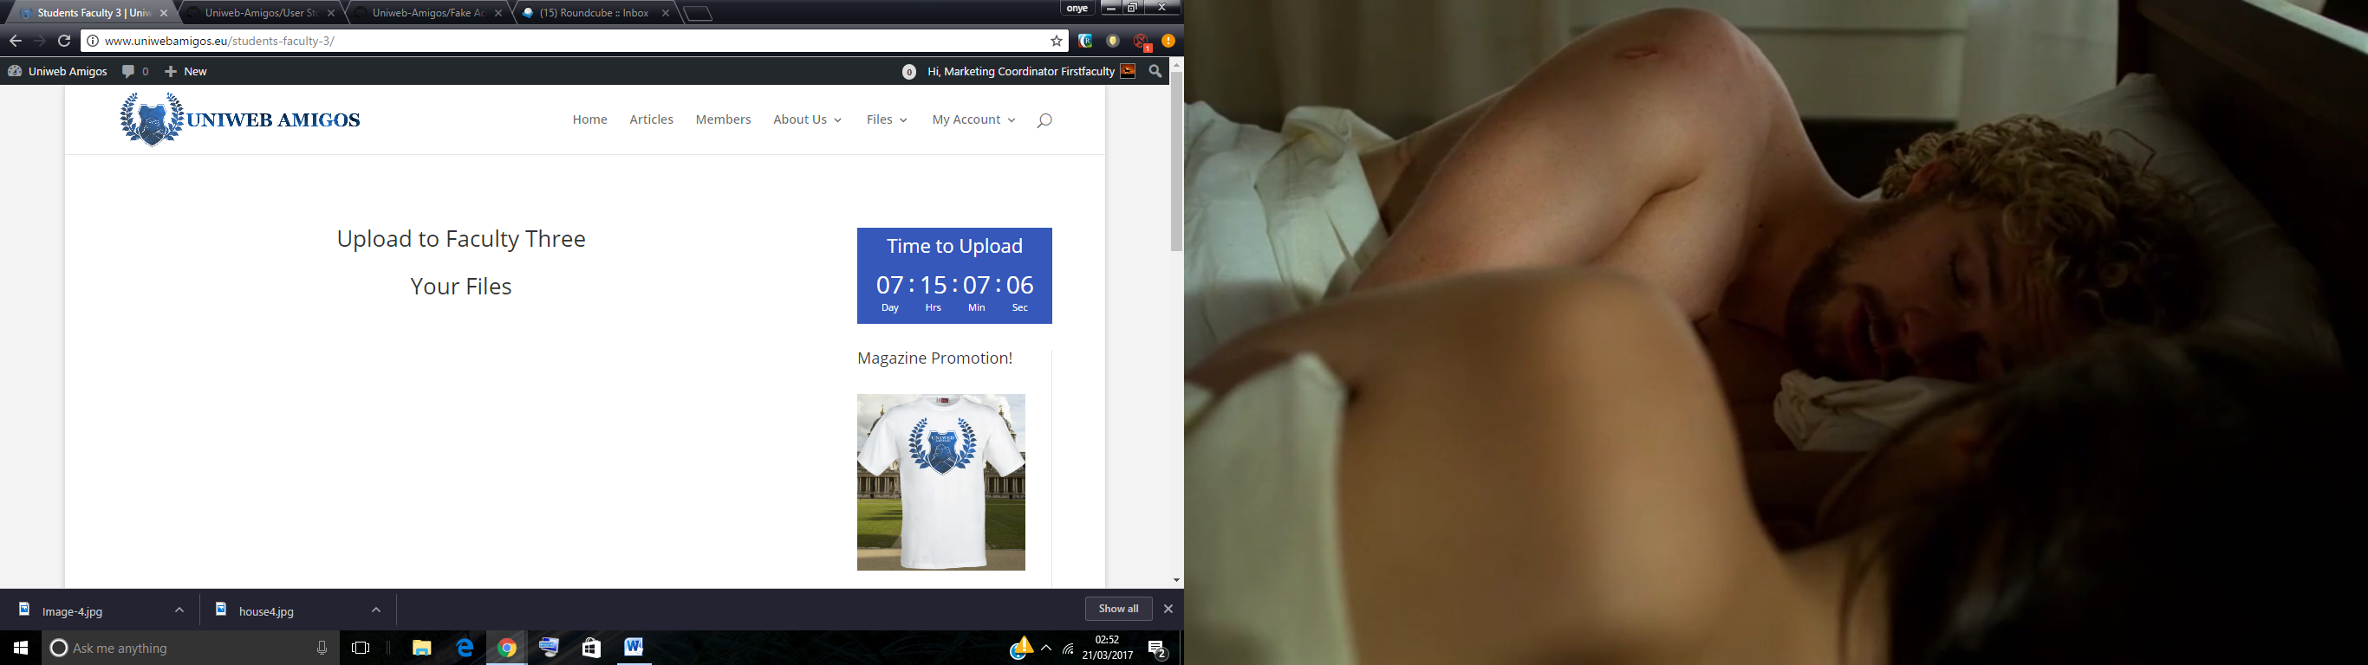

I want students to not be able to submit any new submissions after the closure date

I want students to be able to edit their submissions before the final closure date

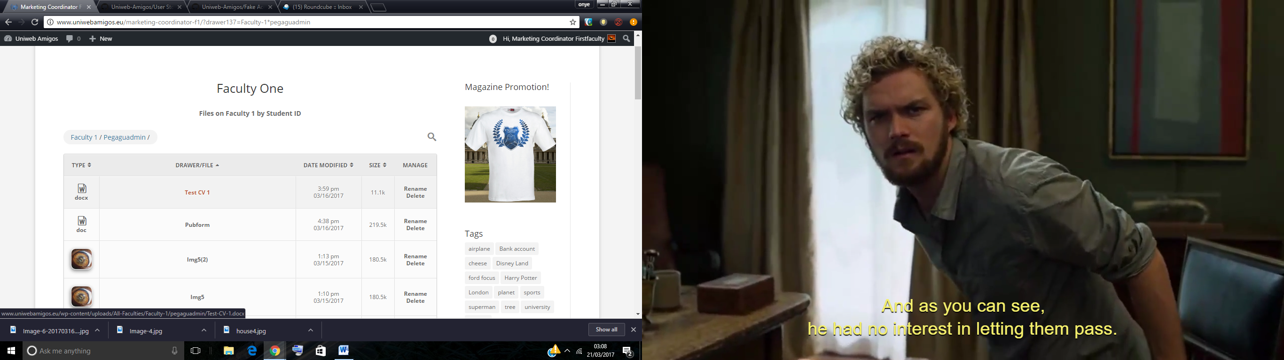

Can download files